# **Sprint Review Meeting – Sprint 1**

## Purpose

* The purpose of sprint review meeting for current state/sprint is to engage with the audience by demonstrate certain main function of the system and also collect useful feedback from the audience.
* For this sprint, the review meeting allow to show up to half part of the entire system which included management module, customer module and supplier module due to the project will be divided into 2 sprints which is 3 weeks per sprint.

## Goal

* One of the goal for this review meeting is to have better engage and communicate with the audience by providing demonstrate and Q&A section during the meeting.
* Another goal for this review meeting is to make sure that the requirements and user stories are fulfilling correctly so that it will indirectly increase the user satisfaction.
* Another goal for this review meeting will be the scrum team able to enhance the requirements and user stories after received all the useful feedback from the audience during the meeting.

## User Stories (Review Meeting)

|  |  |  |
| --- | --- | --- |
| **User Stories** | **Status** | **Satisfied/Dissatisfied** |
| allow staff to delete staff detail | Started | Satisfied |
| allow system to remember username | Started | Satisfied |
| allow staff to find back the password | Started | Satisfied |
| allow system to verify the staff position | Started | Satisfied |
| allow staff to change own password | Started | Satisfied |
| allow staff to retrieve staff detail | Started | Satisfied |
| allow staff to update staff detail | Started | Satisfied |
| allow staff to create new staff detail | Started | Satisfied |
| allow staff to login | Started | Satisfied |
| allow staff to generate summary report | Unstarted | - |
| allow staff to generate detail report | Unstarted | - |
| allow staff to generate exception report | Unstarted | - |
| allow staff to view the redeem transaction | Started | Satisfied |
| allow staff to add redeem transaction | Started | Satisfied |
| allow staff to update customer detail | Started | Satisfied |
| allow staff to retrieve customer detail | Started | Satisfied |
| allow staff to add new customer detail | Started | Dissatisfied |
| allow staff to delete customer detail | Started | Dissatisfied |
| allow staff to delete supplier detail | Started | Satisfied |
| allow staff to update supplier detail | Started | Satisfied |
| allow staff to view supplier detail | Started | Satisfied |
| allow staff to add new supplier detail | Started | Satisfied |
| allow staff to check for payment transaction | Unstarted | - |
| allow staff to make payment | Unstarted | - |
| allow staff to add in payment detail | Unstarted | - |
| allow staff to add on product quantity | Unstarted | - |
| allow staff to delete product | Unstarted | - |
| allow staff to update product price | Unstarted | - |
| allow staff to view product detail | Unstarted | - |
| allow staff to register for new product | Unstarted | - |

## Customer Feedback 1

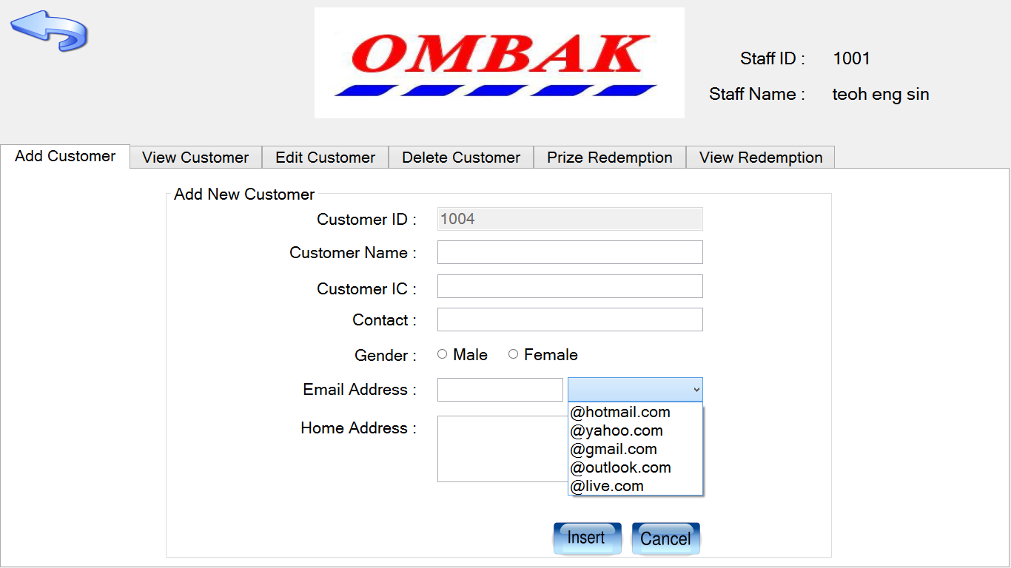

Figure 1: Show the interface of user story “allow staff to add new customer detail”

By default, the input field for the email address will be a text field but the customer feel that the input field for the email address will not be user friendly enough. Therefore, the scrum master suggested to the scrum team by adding one more drop down list to the input field for the email address. The customer agree with the suggestion from scrum master and finally the customer is also satisfied with the new input field for the email address.

## Customer Feedback 2

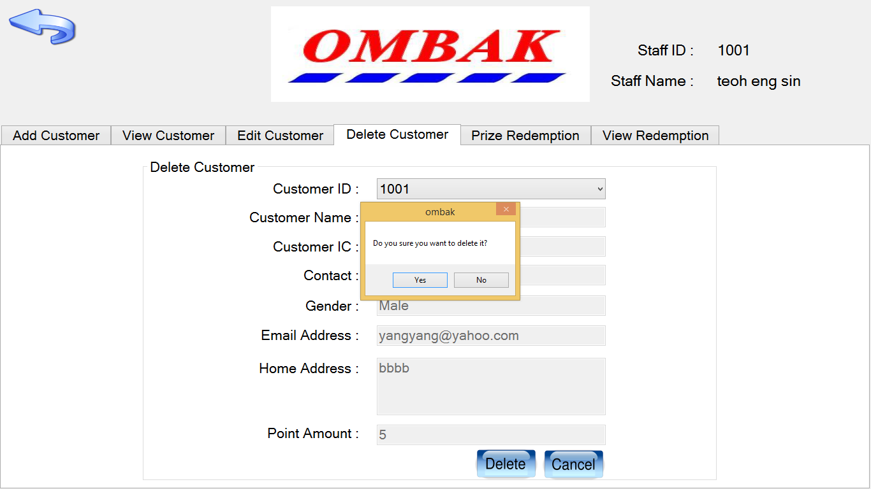

Figure 2: Show the interface of user story “allow staff to delete customer detail”

By default, the system do not provide the confirmation message for the user to double confirm whether the user really want to delete the customer detail or not but the customer say that he/she scare himself/herself may miss click on the delete button and the customer detail will be deleted directly. Therefore, the scrum master propose a solution to the scrum team to overcome this kind of miss click problem occur which is add in one more confirmation message after the user click on the delete button. In this case, it will convenience the user who using the system and may directly increase the reliability of the system as well.